GARDENING BY THE MOON

CRAPE MYRTLES – DARLINGS OF THE SOUTH

Submitted by

Dr. Robert E. Moon

July, 2021

Crape myrtle trees are the darling plant of the south. They flower for most of the summer providing long lasting blooms of white, pink, red, or purple. Some varieties are determinate and will grow only 6 to 8 feet in height, some varieties are dwarf and can be planted as shrubs, and where there is room for height, some varieties will soar to 25 or 30 feet.

In many instances, the natural beauty of crape myrtles is limited when homeowners perform crape murder. Crape murder is when you cut the tree back from the top just leaving stubs (see picture below). During the winter is the best time to prune crape myrtles. Crape myrtles are best grown as trees and should be pruned as trees. Follow these guidelines when pruning crape myrtle: remove low hanging branches that interfere with walkways; remove broken and dead branches; remove crossover or rubbing branches; remove sucker growth off the base of the trunk or on the trunk; and remove any branches growing into your home structure. Old seed heads do not need to be pruned. They will fall off naturally. Crape “murder” will shorten the life of your tree.

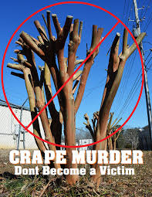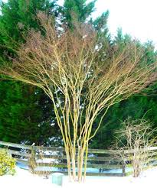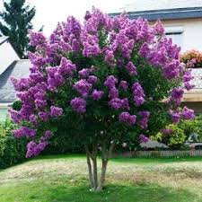
Crape Murder Correct Pruning Tree pruned correctly

If you are considering adding crape myrtle to your yard, I suggest you refer to this link for the TAMU Aggie Horticultural data base for crape myrtle varieties and sizes for Texas.
https://aggie-horticulture.tamu.edu/databases/crapemyrtle/index.html
Crape myrtle have some overwintering insects and diseases that can be controlled by spraying thoroughly until runoff with Neem Oil. This product is a safe, non-toxic pesticide for your garden and landscape that is also friendly to the environment and still effective. Neem Oil is your friend and a good answer for all these concerns and you can use it on all trees, shrubs, ground cover and even in your garden. It means you can keep only one product in your garage for control of most insects, some diseases and mites.

You can also control scale and aphids with Bayer Tree and Shrub Granular plant food and insecticide. For diseases you can control powdery mildew and sooty mold with Daconil.

The beauty provided by crape myrtles is worth the effort to prune them correctly and control insects and disease because they will enhance your landscape and provide you color throughout the summer.

